Technical or Specialized Dictionary

What is Technical / Specialized Dictionary
# Source: AI Source: Provided by: [Data Path: Persons Table -> ID Column: 1, Name_En Column: Motasem Essam] -> From: [Chatgpt (GPT-4-turbo)] on [7/29/2025]
A Technical or Specialized Dictionary provides definitions and explanations of terms that are specific to a particular field or discipline. These dictionaries are essential tools for professionals, students, and translators who need precise, context-specific meanings in areas like law, medicine, science, engineering, finance, and more.

🔹 Key Features of a Technical / Specialized Dictionary
# Source: AI Source: Provided by: [Data Path: Persons Table -> ID Column: 1, Name_En Column: Motasem Essam] -> From: [Chatgpt (GPT-4-turbo)] on [7/29/2025]
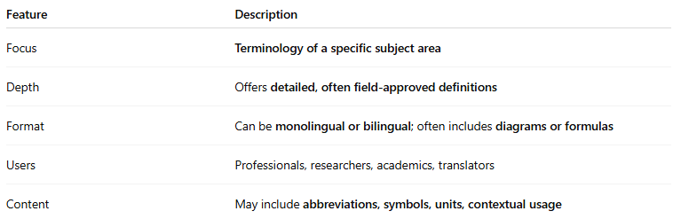
Feature | Description
Focus | Terminology of a specific subject area
Depth | Offers detailed, often field-approved definitions
Format | Can be monolingual or bilingual; often includes diagrams or formulas
Users | Professionals, researchers, academics, translators
Content | May include abbreviations, symbols, units, contextual usage

🔹 Examples of Technical / Specialized Dictionaries
# Source: AI Source: Provided by: [Data Path: Persons Table -> ID Column: 1, Name_En Column: Motasem Essam] -> From: [Chatgpt (GPT-4-turbo)] on [7/29/2025]
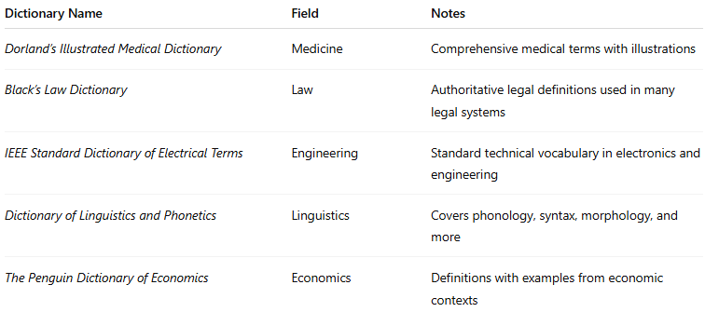
Dictionary Name | Field | Notes
Dorland’s Illustrated Medical Dictionary | Medicine | Comprehensive medical terms with illustrations
Black’s Law Dictionary | Law | Authoritative legal definitions used in many legal systems
IEEE Standard Dictionary of Electrical Terms | Engineering | Standard technical vocabulary in electronics and engineering
Dictionary of Linguistics and Phonetics | Linguistics | Covers phonology, syntax, morphology, and more
The Penguin Dictionary of Economics | Economics | Definitions with examples from economic contexts

🔹 Advantages
# Source: AI Source: Provided by: [Data Path: Persons Table -> ID Column: 1, Name_En Column: Motasem Essam] -> From: [Chatgpt (GPT-4-turbo)] on [7/29/2025]
- Ensures precision and clarity in technical communication
- Assists with understanding domain-specific materials
- Supports translation and localization in professional fields
- Enhances academic and professional writing

🔹 Use Cases
# Source: AI Source: Provided by: [Data Path: Persons Table -> ID Column: 1, Name_En Column: Motasem Essam] -> From: [Chatgpt (GPT-4-turbo)] on [7/29/2025]
- Industry-specific documentation and manuals
- Academic research and writing
- Professional translation and interpretation
- Training and certification in specialized domains

